Abstract Title for ICMFS-2022
M. First^{1*}, M. Second², L. Third³, and Z. Last-Author¹
¹Department of Physics, UC Berkeley, Berkeley CA, USA
²Materials Science Division, ANL, Argonne IL, USA
³Institute for Theoretical Physics, University Hamburg, Hamburg, Germany
*E-mail: ****@***.**.**

Abstracts for the ICMFS2022 [1] should be prepared according to this template. Abstracts are limited to one page including figures and tables. Set margins at least to 1 in or 2.5 cm throughout. Use Times New Roman font, font size 12 points, with 12 pt line spacing and additional 6 pt spacing after each paragraph.
The abstract title should be in capital letters, bold face, with center alignment. Author list and affiliations should be centered as well; for the abstract body use justified alignment. Leave single empty lines between title, author list, affiliations, and main body of your abstract.
Abstracts must be submitted via the online submission system before February 19, 2022.
You will receive an automatically generated confirmation email after submission of your abstract.
Acceptance notifications will be emailed by April 5, 2022.
Acknowledgements appear at the end of the body text, e.g. this work was supported by AAA under grant no. 19-24-9-2010.
[1] M. First, M. Second, L. Third, and Z. Last-Author, Nature (2010) submitted.

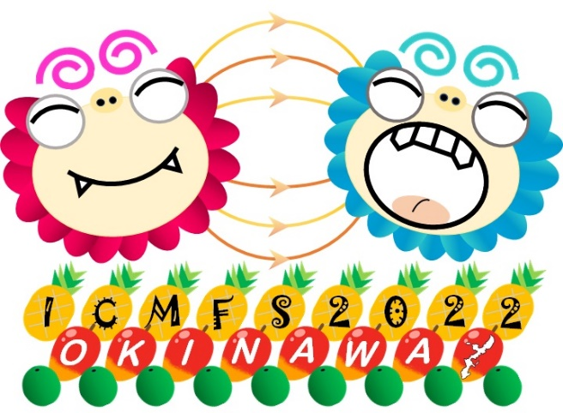
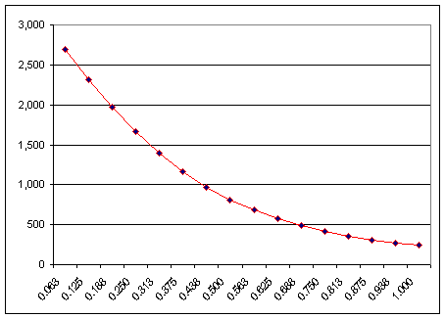
Fig. 1: Text for the image goes here
Fig. 2: Text for the graph goes here.

