Title

K. Kyoto¹, M. Mml^{1,2}, ...

¹Institute for MML, MML Univ., Kyoto, 000-0000, Japan.
²National Institute for MML, ....

Abstracts should be prepared as a Portable Document Format (PDF) file.
The abstract should contain 2 pages document. Text, mathematical expressions, graphs, Tables, and figures are allowed. The text must be typed with Times New Roman. The left, right, top and bottom margins should be 25 mm. The document will be printed in black and white.
The text should contain the following items in the exact given order and written in English:
1) Title of the paper: 14pt size font, use bold.
2) Author (initials or first names before surnames), separated by commas and each followed by a footnote letter (1, 2, 3...) referring to the respective address (12pt size font).
3) Addresses, each preceded by a footnote letter referring to the respective author name(s) (12pt size font).
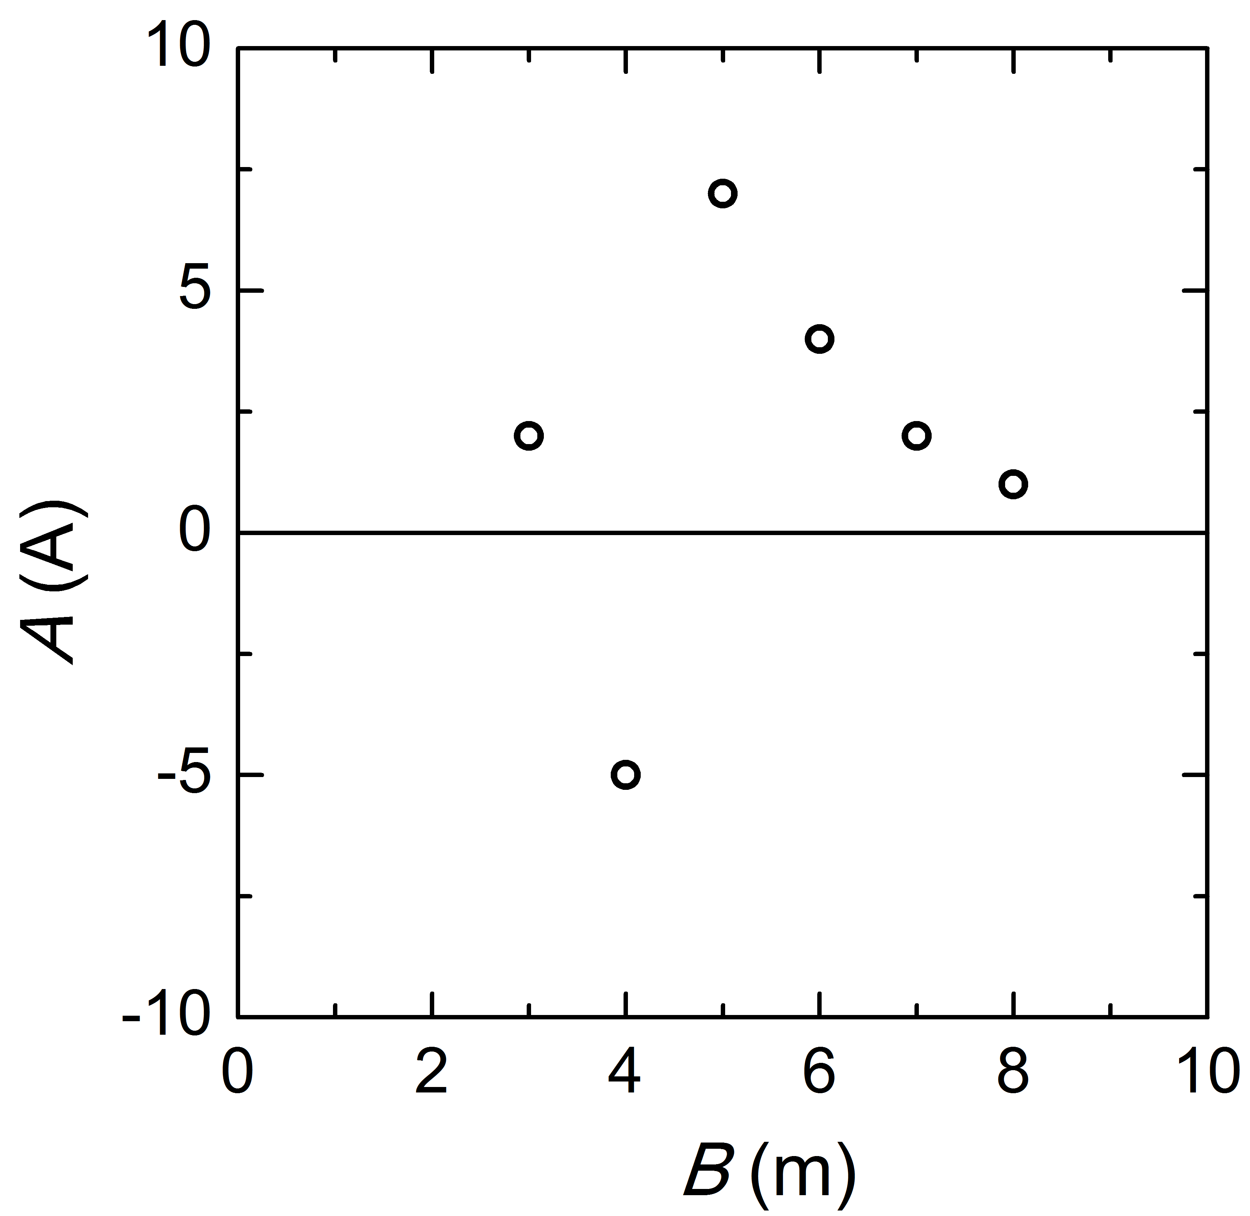

Fig. 1 A dependence of B.
4) References should be limited to the most relevant literature. They should all be cited in the text, numbered in square [] brackets consecutively in order of first appearance.
5) Tables should have a clear structure, with simple column headings that include all units in parentheses.
6) Figures must be sufficiently large in order for all details not to become illegible in printed form. Figure captions should be 12pt size font.

Authors are asked to follow as close as possible the template provided.

[1] M. Mml and K. Kyoto, Phys. Rev. Lett. 1, 1 (2012).
[2] ....
[3] ....

